World Language Supplies:

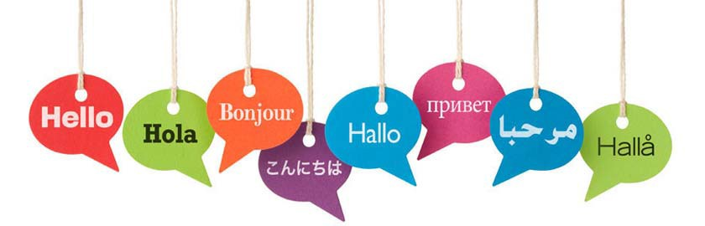
ALL World Language CLASSES:
- Loose‐leaf paper
- Writing utensil
- Folder or binder
French Language CLASSES:
- Composition book with folders
(may reuse from previous French class)

